How to Install Ubuntu

Turn your computer tapping F12 to select a boot device. You can then use the arrow keys, to select either USB or Disc Drive.

Click Install

Once Ubuntu has booted, you will be presented with a screen that looks like this:

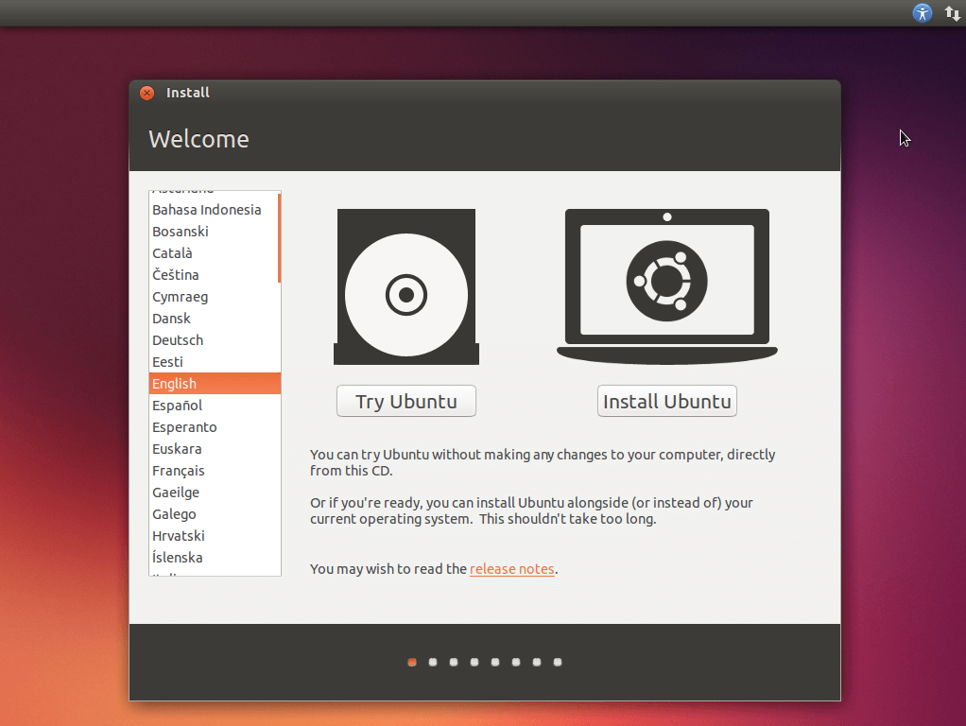

Click Install Ubuntu to install

2. Check both Boxe
We recommend checking both boxes.......
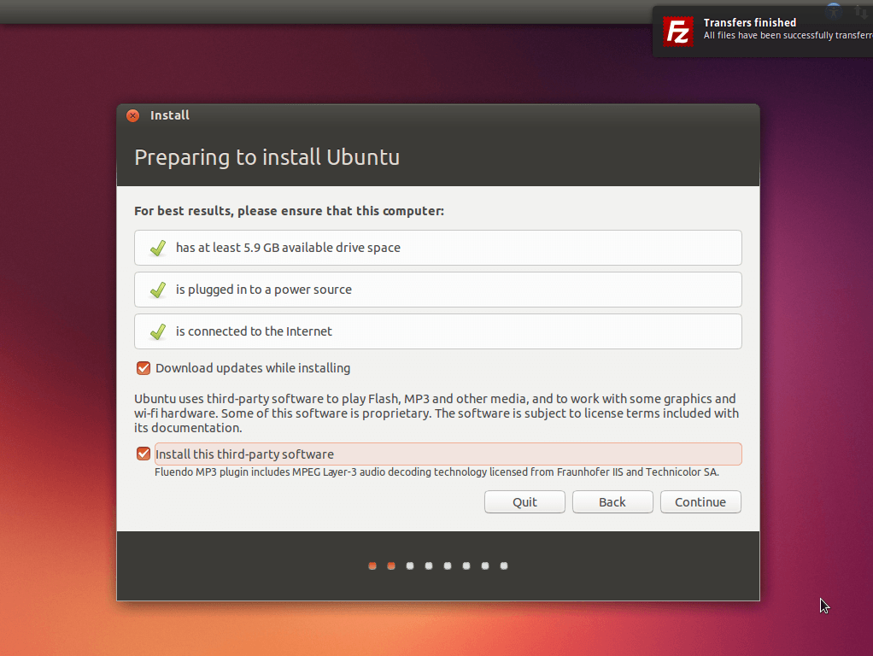

3. Choose How to Install
Yours will probably look a little different to mine here.
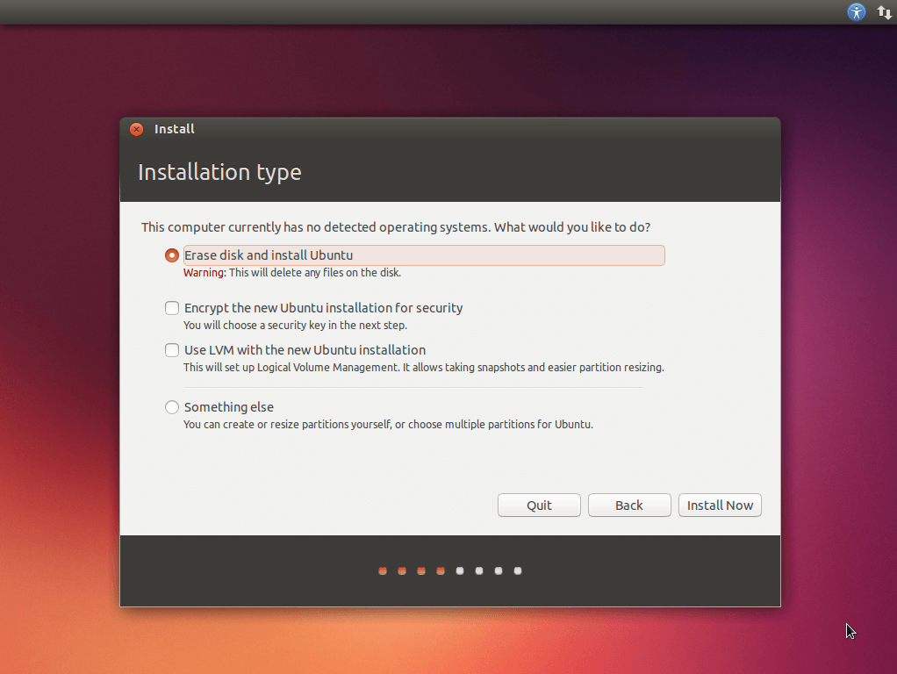

4. Partition (Maybe)
This step you may be required to partition manually
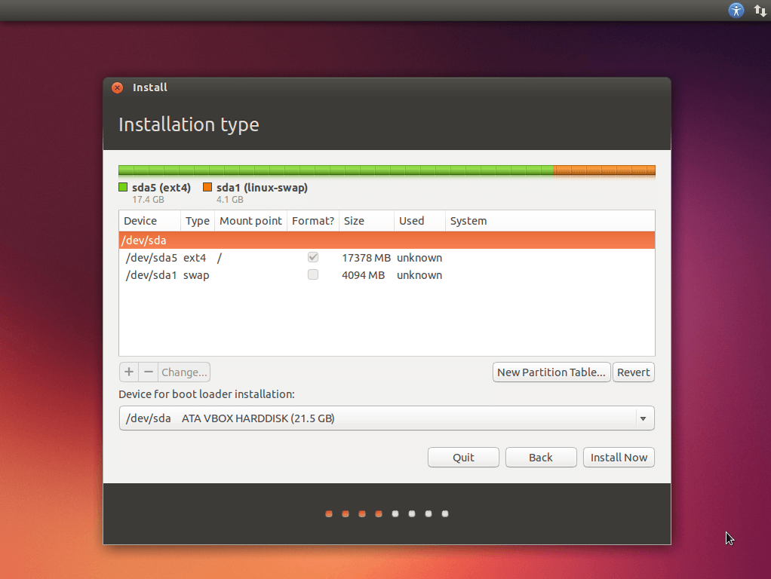

5. Choose your Location
Now you get to choose your location by dropping a pin on this nifty looking map.
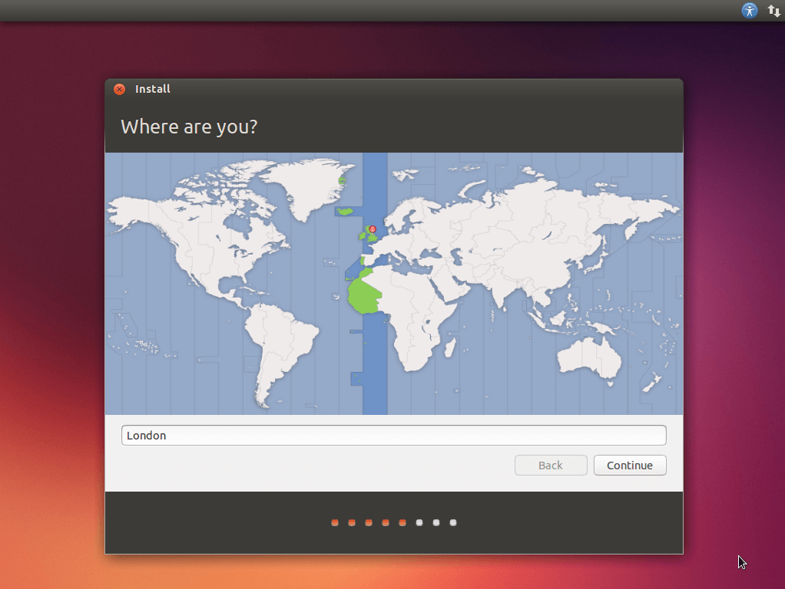

6. Choose your Keyboard Layout

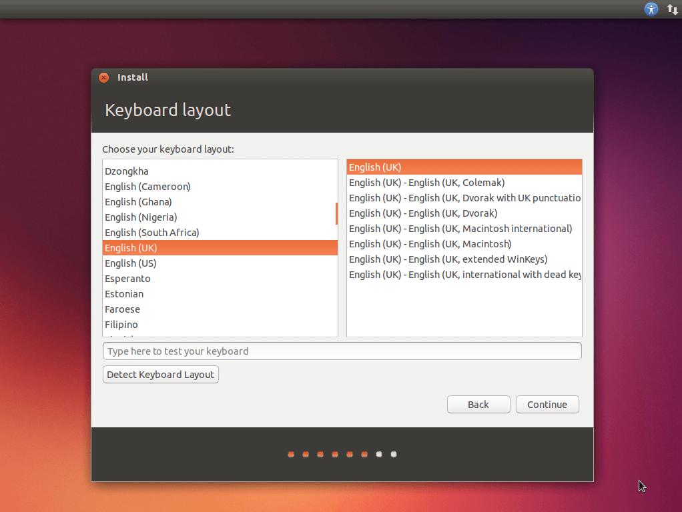

7. Set a Username and Password
Now you get to enter your name,your username , a password :
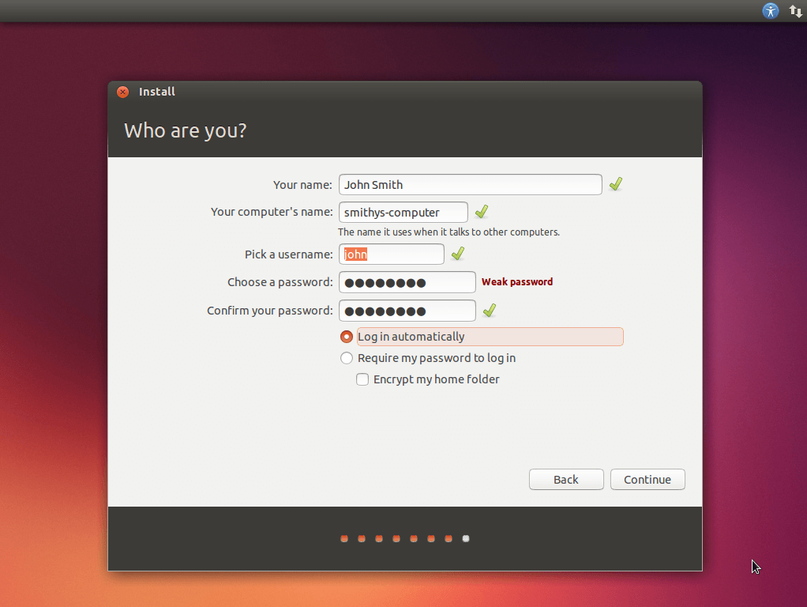

8. Sign in to Ubuntu One
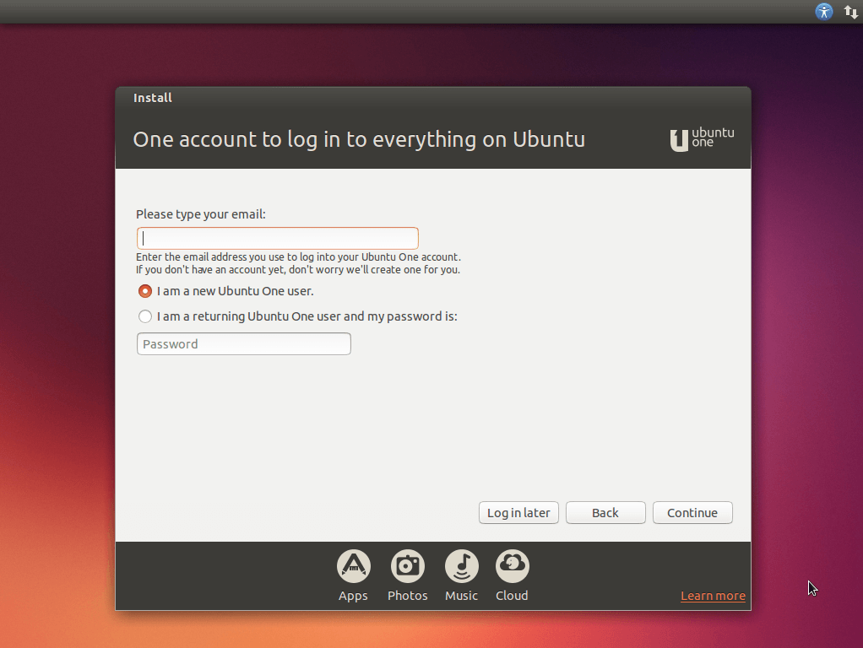

9. Sit Back and Relax
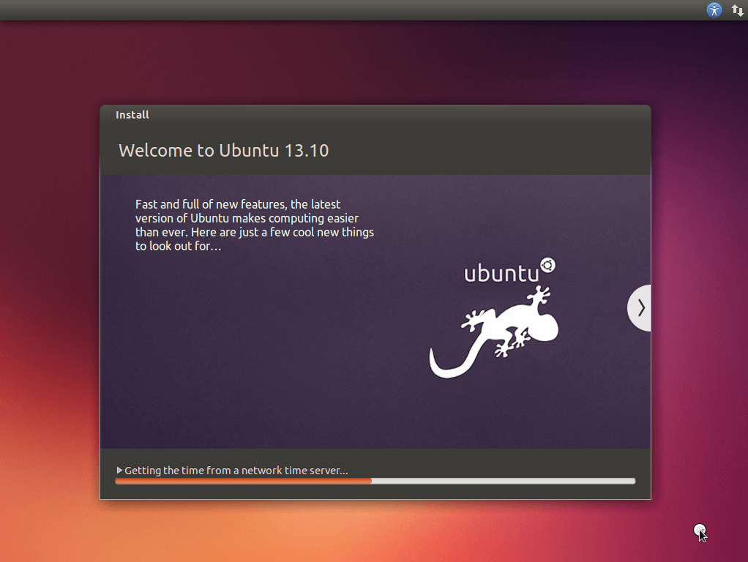
10.Finish Installation
you shoud Restart than enter your username and password,Let's use ubuntu.

